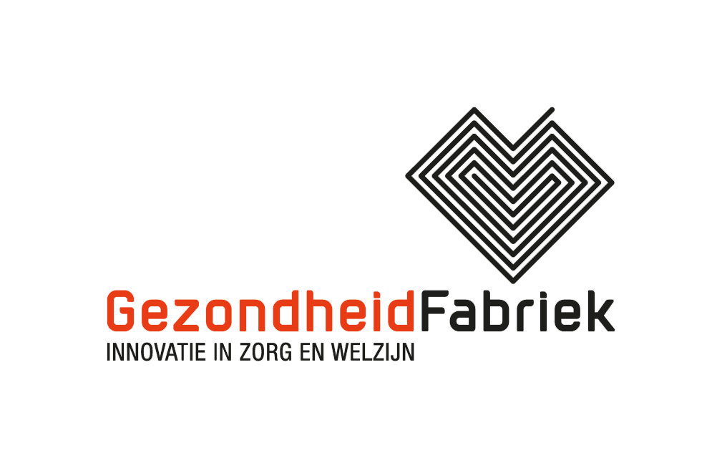

GezondheidFabriek intake / Project idea

GezondheidFabriek is a not-for-profit, open learning- and working environment. Projects are screened on partnership, sharing of Intellectual Property, the use of open source and privacy conditions

Note: GezondheidFabriek itself does not have financial funds nor does it grant financial support to projects

Please consult our project support procedure before filling in this document

- Contact
Project initiator :
Project name :
Contact person :
Phone :
E-mail :

- Problem definition
To which question and/or challenge will your project contribute (max. 70 words)?

- Project objective
Describe the objective of the project, and specifically, the expected benefits for the target group (max. 70 words).

- Results
Describe the direct results of the project (products, services, processes, max. 50 words).

- Activities
Describe which project activities will be carried out where, when, and with whom (max. 100 words).

- Connection to the goals of GezondheidFabriek
Explain and illustrate how the project connects to the mission and goals of GezondheidFabriek, as described at the bottom of this document (max. 70 words).

- Innovation
What makes the project innovative (max. 70 words)?

- Investment budget and financing plan
Give an indication of the total investment and the way in which the project will be financed (max. 30 words).

About GezondheidFabriek

*Mission statement and goals
GezondheidFabriek wishes to contribute to a healthy and social society by stimulating collaboration and facilitating innovation projects. To this end we have created an open learning- and working environment combining technological- with social innovation. The personal needs and aspirations of people are always at the heart of our activities.

Please send your project idea to Sandra Migchielsen. We will contact you within 1 week of receiving your submission.
Sandra Migchielsen, sandra@gezondheidfabriek.nl, +31363690056

June, 2018

